Dedicated/Shared/ADW/ATP/JSON/APEX with ORM Stack

Contents

1. Introduction 1
2. Workflow diagram to deploy the stack 2
3. Create Stack 3
4. Plan the Job 8
5. Apply the Job 9
6. Verify in the Console 11
7. Destroy the stack 12

Introduction

Autonomous Database provides an easy-to-use, fully autonomous database that scales elastically, delivers fast query performance, and requires no database administration.

With your database, you get a completely dedicated compute, storage, network, and database service, providing the highest security, isolation, and governance levels.

When you create an Autonomous Database, you can deploy it to one of three kinds of Exadata infrastructure:

Autonomous Database on Shared Exadata Infrastructure

Simplify data-driven solutions. Analyze all your data using self-service data integration and analysis capabilities, including built-in text, spatial, machine learning and graph analytics. Develop applications using low code Oracle APEX or your favorite open source frameworks.

Reduce data management costs. Oracle autonomously operates all aspects of the database lifecycle, from database placement to backup and updates. And, you only pay for what you use.

Autonomous Database on Dedicated Exadata Infrastructure

A private cloud in public cloud choice. A completely dedicated compute, storage, network and database service for only a single tenant, providing for the highest levels of security isolation and governance.

Autonomous Database for Analytics and Data Warehousing

Oracle Autonomous Data Warehouse is the world's first and only autonomous database optimized for analytic workloads, including data marts, data warehouses, data lakes, and data lakehouses.

Autonomous Database for Transaction Processing and Mixed Workloads

Oracle Autonomous Transaction Processing provides a self-driving, self-securing, and self-repairing database service that can expand quickly to meet the demands of mission critical transaction processing and mixed workload applications.

Autonomous JSON Database

Oracle Autonomous JSON Database is a feature-scoped service for storing and retrieving JSON document collections using SQL or Document APIs. Development which requires a significant amount of non-JSON data must use Autonomous Database for Transaction Processing and Mixed Workloads on either Shared or Dedicated Infrastructure.

Oracle APEX Application Development

Oracle Cloud Infrastructure (OCI) delivers APEX low-code application development on the industry’s first and only Autonomous Infrastructure as a fully managed service that is pre-configured and ready to use, with elastic scalability, security, high availability, global access via regional cloud data centers, and the lowest total cost of ownership.

Workflow diagram to deploy the stack

Below diagram shows how the Terraform Artifact are applied in the OCI. While creating a ORM stack, using terraform deliverables Init, Plan and Apply is the flow to provision the resource in the OCI. We can have the deliverables in any of below.
- GitLab/GitHub Repo
- Bitbucket
- Can be in folder/.zip in the local disk
- Object Storage Bucket
- Can be in compartment
- Oracle provided Template



Create Stack

Note: In this example creating stack for ATP is explained.

Go to OCI Console Developer Services Resource Manager Stacks select the compartment Create Stack

My Configuration Folder Browse Upload

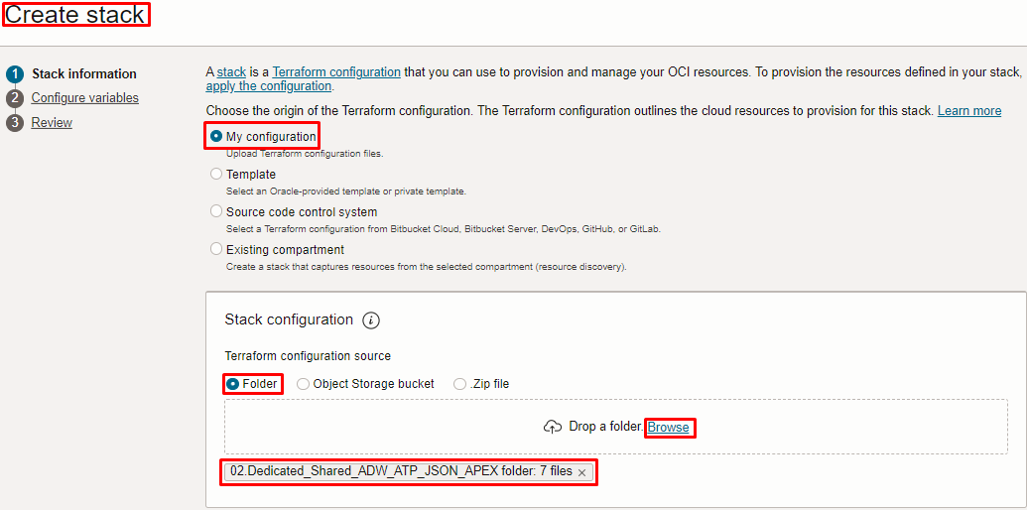

Select the parameters as shown below

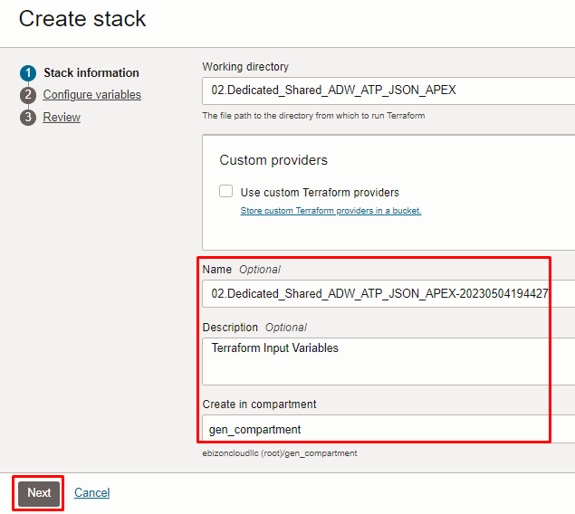

Click “NEXT”

Select the ATP Configuration parameters as per the below screen,

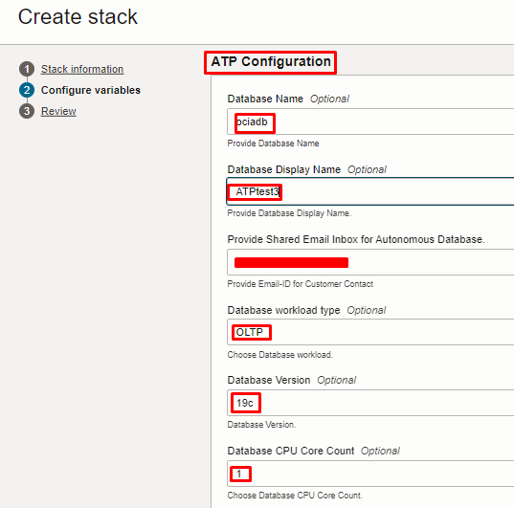

NOTE: under the “Database Workload Type” option, can select any one of the below option
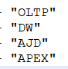
OLTP for ATP, DW for ADW, and so on.

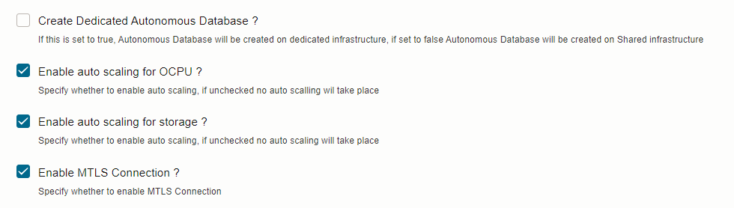

Note: In the above “Create Dedicated Autonomous Database ?” option
Selecting “false” option: Autonomous Database will be created on Shared infrastructure
Selecting “true” option: Autonomous Database will be created on Dedicated infrastructure

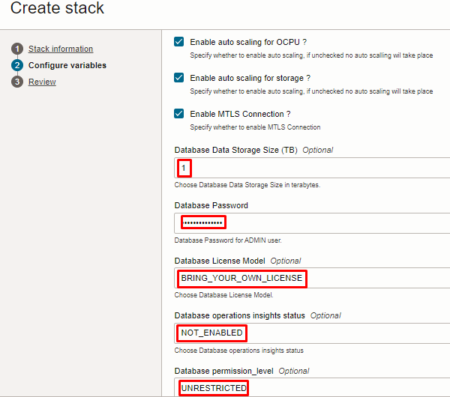

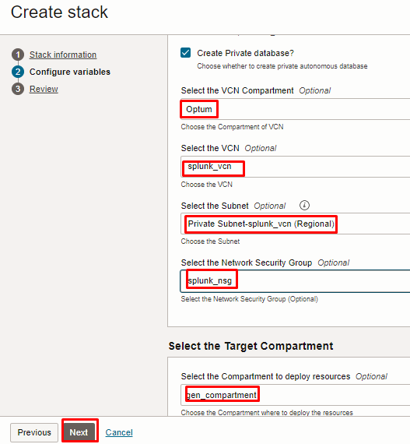

Click “NEXT”

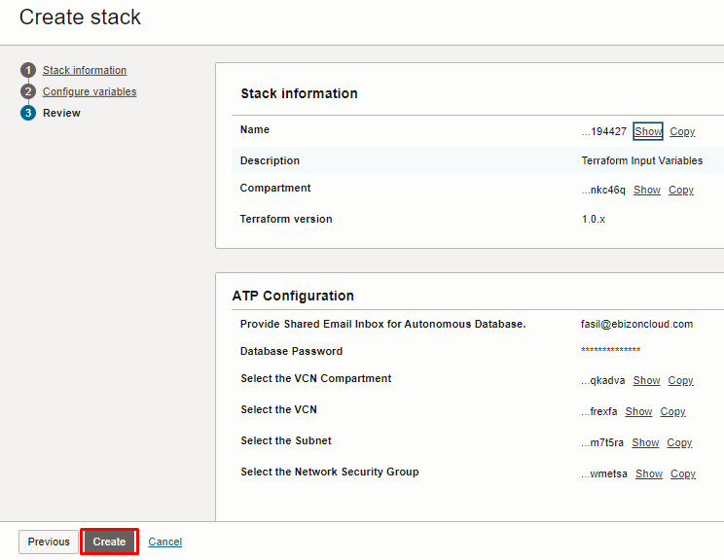

Click “CREATE”

Plan the Job

Click the “Plan”

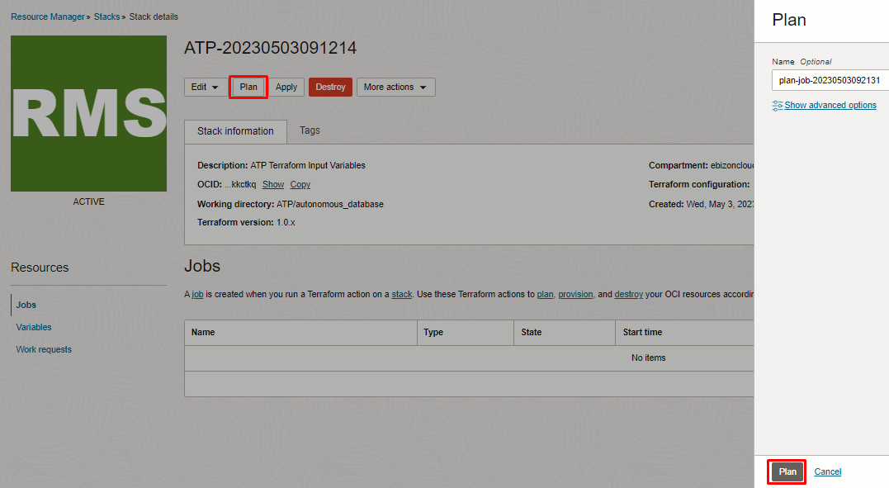

Verify the Plan is successful.

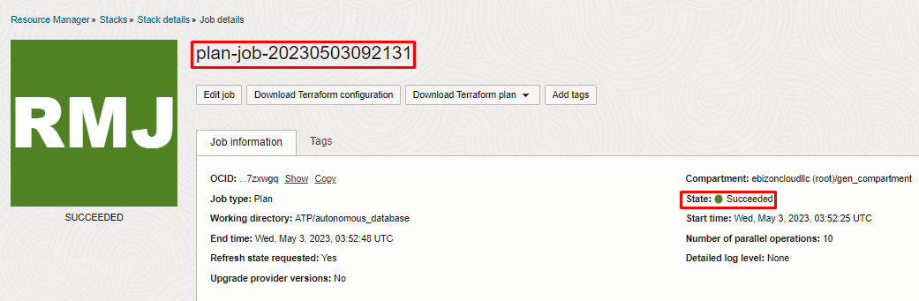
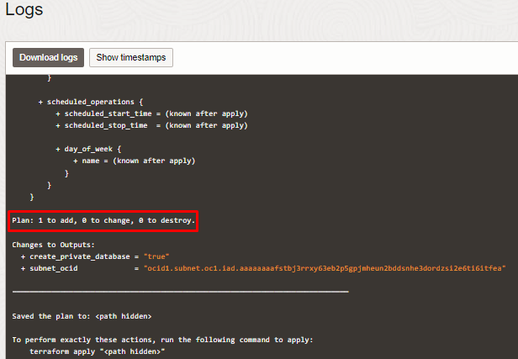

Apply the Job

Once the “plan” is success, now click “Apply”

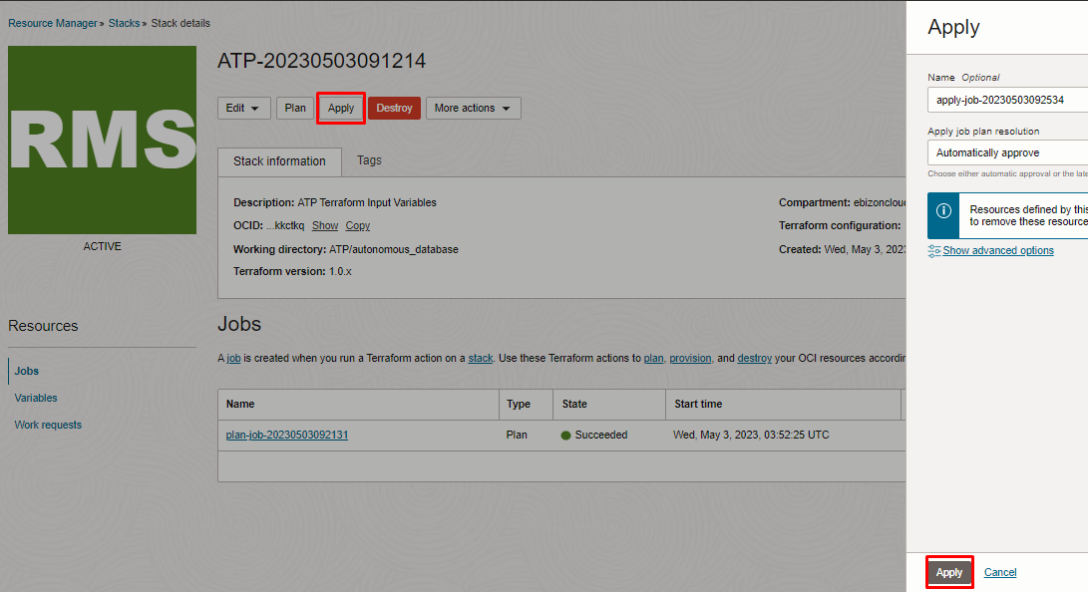

Verify the Apply is successful.

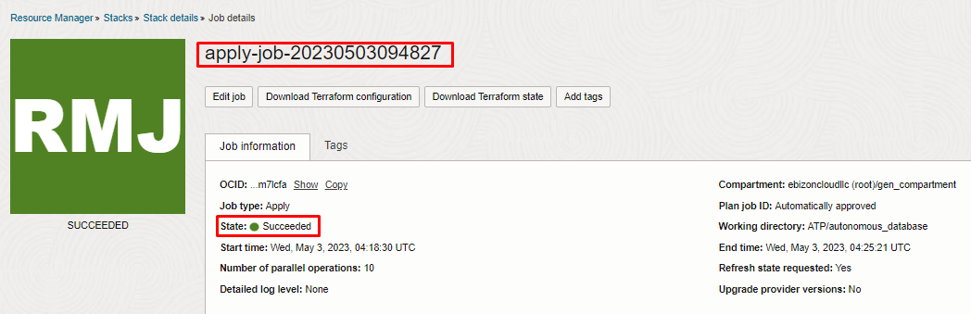
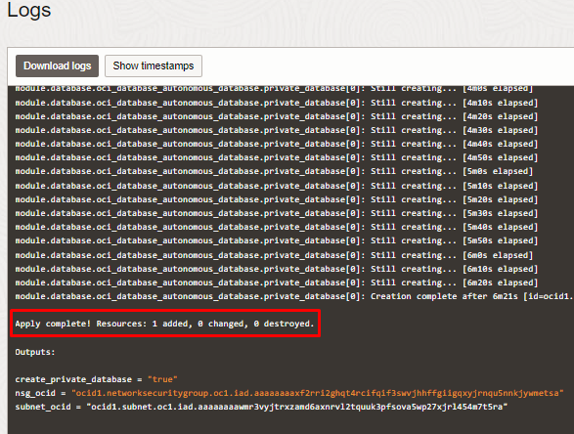

Verify in the Console

Go to OCI Console Oracle Database Autonomous Database

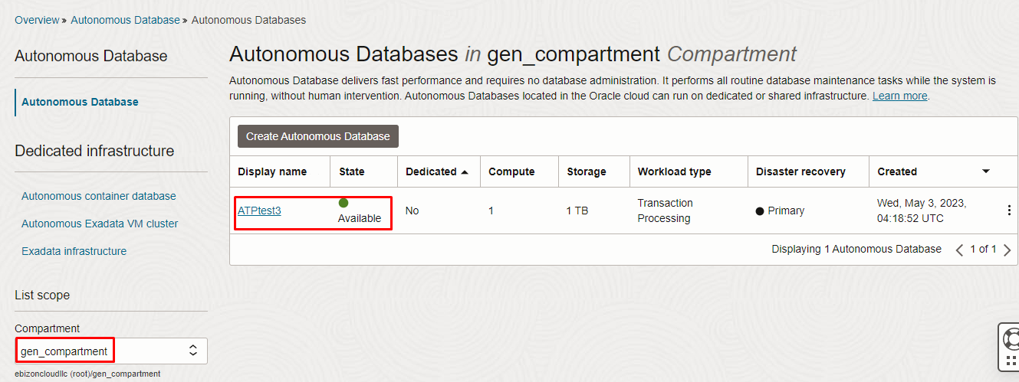

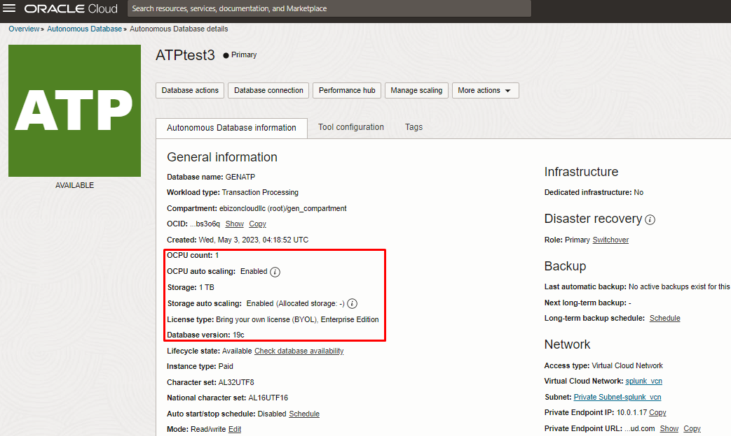

Destroy the stack

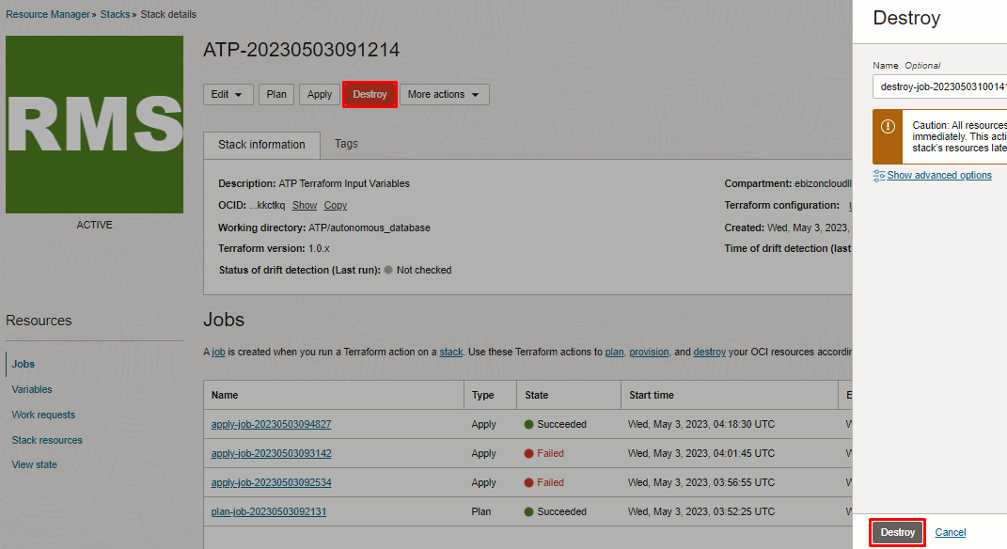

# END #

